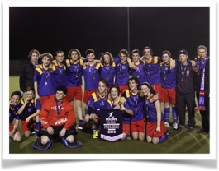

**2023 COME AND TRY HOCKEY**

**ST BEDE’s HOCKEY CLUB FREE CLINICS**

www.stbedeshc.org.au

St Bede’s Hockey Club invites **new and experienced players** to come and try Hockey with us. Whether you’ve enjoyed playing School Hockey or have never picked up a stick before you are welcome to come down and have a go at this exciting team sport.

These clinics will be run by our experienced junior coaches and will cover a range of beginner and advanced skills. **All equipment will be supplied.** Just bring your runners.

Dates: **Wednesday 8th March 3.30 pm to 4.30 pm**

**Wednesday 15th March 3.30 pm to 4.30 pm**

**Wednesday 22nd March 3.30 pm to 4.30 pm**

**# Looking for Under 14, U/16 and U/18 players.**

Where: **St Bede’s College Tennis Courts (Dixon St entry).**

Winter Season: **Starts 5th May to early September with Junior Games on Friday Evenings.**

We look forward to seeing you there!

Dave Byrnes (Junior Coordinator)

0418 572 535

or Craig Edmonds 0422 526 056

For further information contact:

[juniors@stbedeshc.org.au](mailto:juniors@stbedeshc.org.au)